**SYSC 3010 A: Project Proposal**

Line-Following Assistive Device (L.A.D)

**Last Revised: October 4th, 2019**

**Group W2**

Denise Mayo

Brannon Chan

Zachary Porter

Erdem Yanikomeroglu

**Figure 1: An example of what the L.A.D. may look like [3]**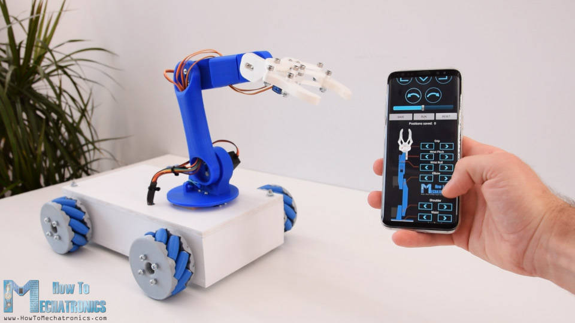

# Project Background

For persons with disabilities who may not always have a primary caregiver in their home, smart assistance technology is invaluable. Robotic assistance can help both persons living with mobility issues and their caregivers by providing assistance with simple tasks for the disabled party and allows the caregiver to perform other tasks (such as cooking, doing laundry or cleaning in another room) without having to worry about being available to fetch items for their dependent.

# Solution Definition

The L.A.D’s primary purpose will be to move around to certain locations in the house using line-detection, pick up a specified item (such as a pill box or a small remote control) using an arm with a camera, and bring it to a user who has limited mobility and/or visual impairment. Regarding the future scalability of this project, the L.A.D will have a camera dedicated solely to driving, which would enable it to move more freely around a given environment. It could also utilize pressure and temperature sensors mounted on the arm’s grippers to measure the force being applied to the object and how hot it is. The L.A.D could also be adapted to many other roles due to its versatility if it were given some minor adjustments, such as warehouse transportation, mining, toxic/radioactive materials handling, bomb defusal, disaster response, and others.

# Project Overview & Scope

We shall demonstrate a simple prototype of one type of assistance robot. This robot will be able to do the following things:

1. Be able to move in front of a table by tracking and following a line on the floor
2. Be able to pick up small objects from a table, where the items shall weigh no more than 100g
3. Be controlled by an android app
4. Relay commands and data to & from the central database

# 

# 

# 

# Technical Specifications

The robot will be implemented in the following stages.

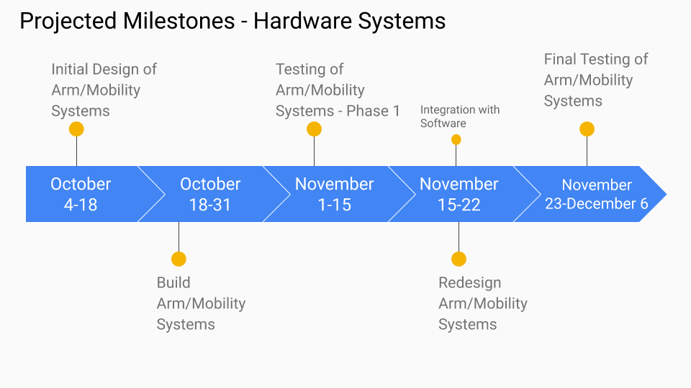

**Figure 2: A projected timeline of hardware system completion**

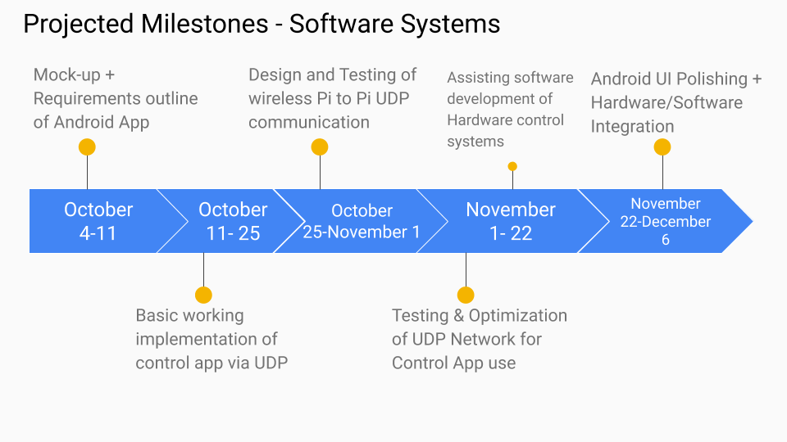

**Figure 3: A projected timeline of software system completion**

# Technical Design

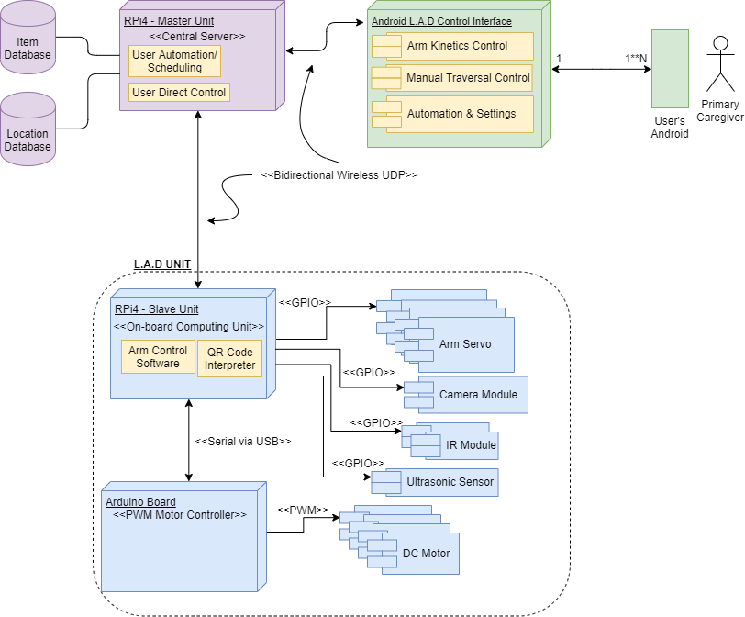

**Figure 4: A high-level UML diagram of the entire L.A.D. system**

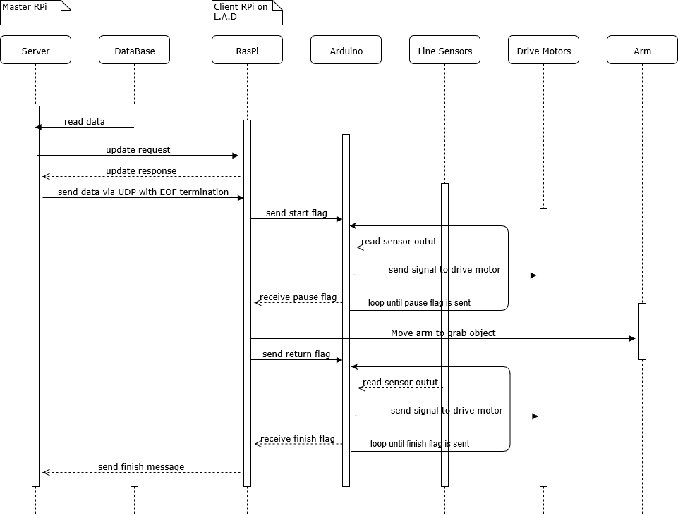

**Figure 5: A sequence diagram showing an example of what function calls to and from the L.A.D. may look like**

**Development Roles**

1. Line-Following Algorithm & Detection- Denise and Zachary
2. Assistance Arm Mechanical Articulation - Denise and Zachary
3. L.A.D - Central Server Communication - Erdem, Zachary and Brannon
4. L.A.D Control via Android user interface - Erdem and Brannon
5. QR Code Reader - Zachary

**L.A.D System Testing Plan**

The testing plan for the L.A.D system will be as follows:

**Mobility System:**

The mobility system consists of the drive wheels, IR light sensors to detect lines (paths), and an ultrasonic sensor to detect obstacles that might cross in front of the L.A.Ds. the mobility system will be controlled primarily by the Arduino with supporting communication with the Pi via GPIO. The Pi can send signals to interrupt the Arduino’s driving process if an obstacle is detected, or if the system reset is initiated.

Testing Steps:

1. L.A.D (using only Arduino) can drive forward, backward, and turn and strafe left, right
2. L.A.D (using only Arduino) can follow paths set out on the floor
3. L.A.D (using only Arduino) can find path again if it has fallen off
4. L.A.D (using Pi and Arduino) can drive and communicate between the Arduino and Pi
5. L.A.D (using Pi and Arduino) can receive commands from the server to control where it drives

**Arm System:**

The arm system will use 3 motors to control the arm and hand. The hand will use a stepper motor to allow for fine control over the hands’ position and grip pressure. The arm’s vertical position will be controlled by a DC motor. There will be a second DC motor on the arm to control the pitch of the hand. Adjustments to the pitch of the hand will allow for picking up of items with just the fingertips, or by gripping around the object.

Testing Steps:

1. Arm can be controlled using a Pi (ie. pushing/lifting light objects)
2. Arm can lift approximately 20g
3. Arm gripping module can hold objects massing 20g without dropping
4. Steps 2 and 3 will repeat with increasing mass until the arm can support 100g.

**Database:**

The database will be part of the server. The database will contain data tables on the location and names of items that the L.A.D can pick up.

Testing Steps:

1. Database on server can store data for object labels, and locations.
2. Data can be read from database and sent via UDP to the L.A.D’s Pi
3. Data can be written/updated easily through the servers’ GUI/CLI

**Android App:**

A user friendly Android app will be created to allow for easy wireless manual control of the L.A.D. This simple, easy to use interface will also allow non-technical users to set up, create or change automated commands issued to the L.A.D, enabling the system to autonomously assist around the house without having the caregiver controlling it

The L.A.D Control App will feature multiple pages for the user:

* Home Page: A simple welcome page the user sees upon opening the app, will allow the user to log into their account and then select from a list of users' L.A.D’s to configure/use.
* Manual Control: This page allows the user to tell the L.A.D to traverse the line forwards or backwards, to stop, and to manually articulate the Arm System via a digital joystick.
* Settings: After selecting a L.A.D on the home page, the user can change configure the L.A.D, change its’ name, when it’s active hours are (i.e: when the L.A.D can enter sleep mode), and other advanced options (for technical/developer use only).
* Automate: Allows the user to create and edit custom commands for the L.A.D. These commands will be created from a list of the L.A.D’s functions, and other simple drag-n-drop style actions/logic. The L.A.D will execute these custom commands at a defined time in the sequential order the user specified.

**References and Citations**

[1] "Store and replay this robot’s movements from your phone", *Arduino Blog*, 2019. [Online]. Available: https://blog.arduino.cc/2019/07/08/store-and-repeat-this-robots-movements-from-your-phone/. [Accessed: 30- Sep- 2019].

[2] C. Toporov, "Line following robot with OpenCV and contour-based approach", *Medium*, 2019. [Online]. Available: https://medium.com/@const.toporov/line-following-robot-with-opencv-and-contour-based-approach-417b90f2c298. [Accessed: 29- Sep- 2019].

[2] "Arduino Line Follower Robot Code and Circuit Diagram", *Circuitdigest.com*, 2019. [Online]. Available: https://circuitdigest.com/microcontroller-projects/line-follower-robot-using-arduino. [Accessed: 30- Sep- 2019]